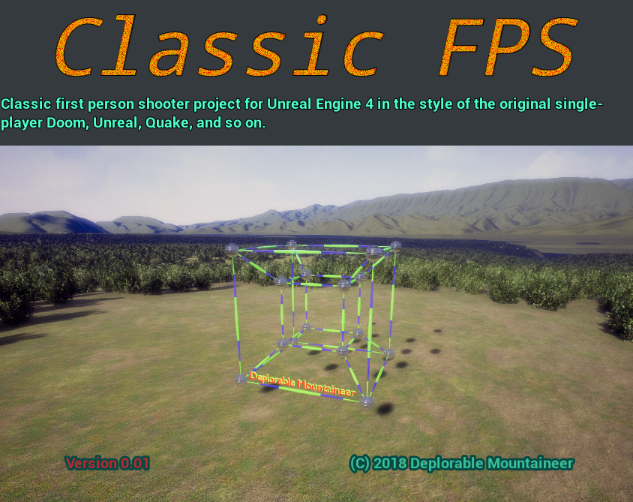
Unique Project ID: {AED64A86-47D8-D36A-F0A9-2093602951A6}
Name: Classic FPS Version 0.01
Description: Classic first person shooter project for Unreal Engine 4 in the style of the original single-player Doom, Unreal, Quake, and so on.
Company: Deplorable Mountaineer
Website: https://deplorablemountain.wixsite.com/games
Copyright: © 2018 Deplorable Mountaineer
Contact: Deplorable.Mountaineer@gmail.com
Palette Colors: #38c098 (Shamrock), #F8BE00 (Amber), #B52930 (Tall Poppy), #10655E (Eden), #ffffff (White), #42484f (Mako), #1EF858 (Malachite), #F89245 (Tan Hide), #A057F8 (Heliotrope), #45F8B5 (Aquamarine), #613F29 (Irish Coffee)


Palette Gradient:


